1. Go to <https://github.com/libsdl-org/SDL/releases/tag/release-2.28.3>
2. “YourPath” is path to airEngine folder on your hard disk. For me it is “F:\Documents\Projects” and full path in my hard disk is “F:\Documents\Projects\airEngine”.
3. Download “Source code (zip)”
4. You will get SDL-release-2.28.3.zip on the hard disk.

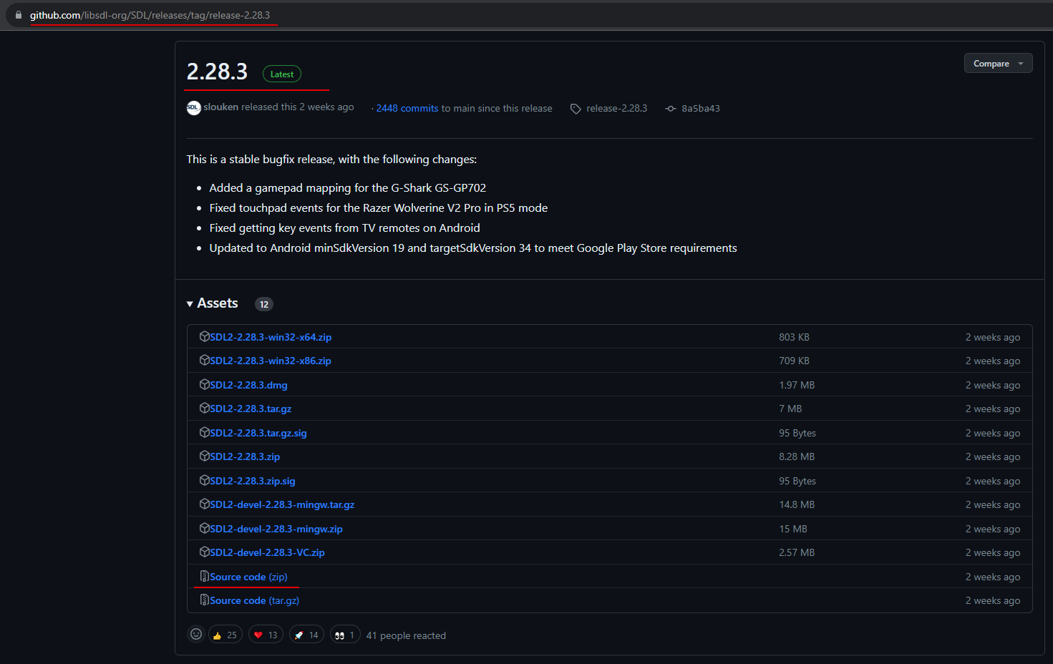

1. Move it in the “airEngine\thirdparty”. For example, I have cloned airEngine into “F:\Documents\Projects” folder. So, now I have this path:

“F:\Documents\Projects\airEngine\thirdparty”

1. Extract zip. That’s what I have in my hard disk:

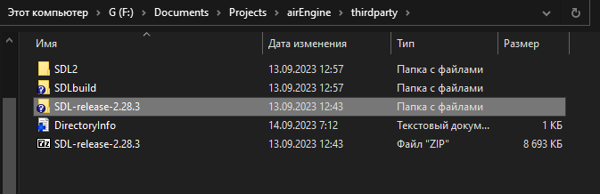

You should have “include”, “src”, “doc” subfolders in SDL-release-2.28.3 if everything is Ok.

1. Now start CMake-gui. And type or browse path to your SDL sources within airEngine. This must be in “Where is the source code”. In “Where to build the binaries” type the path to “airEngine/thirdparty/SDLbuild”. So, my settings are shown below:

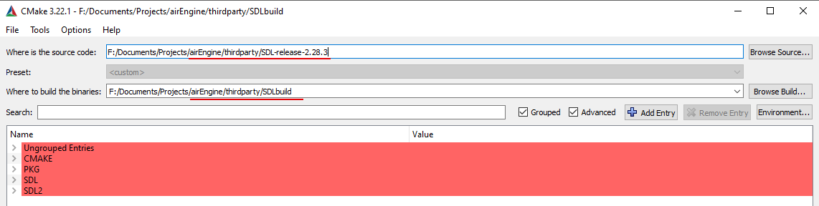

1. Press “Configure” button.
2. Select compiler.
   1. For Linux guys select CodeBlocks-MinGW Makefiles 🡪 Specify native compilers 🡪Next🡪Finish.
   2. For VS guys select Visual Studio 16 2019 or Visual Studio 17 2022🡪Use default native compilers🡪Finish.
3. Do these settings after first configuration (when items are red):
   1. CMAKE_INSTALL_PREFIX path to airEngine/thirdparty/SDL2



1. Configure again🡪Generate🡪Close CMake.
2. Building.
   1. For CodeBlocks programmers launch command prompt🡪cd to “YourPath\airEngine\thirdparty\SDLbuild” folder and call:

mingw32-make

After it have finished call:

mingw32-make install

* 1. For Visual Studio programmers launch SDL2.sln in Visual Studio. Build it.

Build “INSTALL” named project too.

1. After the building copy SDL2.dll or SDL2d.dll into “YourPath\airEngine\bin” folder.